RECONCILIATION OF DAILY CASH BALANCES

Menu: Loan >> Cashiering >> Reconciliation of Daily Cash Balances

User: CASHIER

Step 1: Click NEW Button
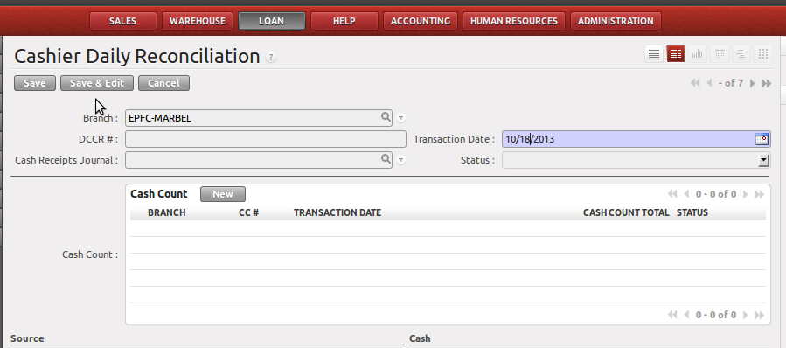

Fill-up Transaction Date and click SAVE AND EDIT button

Step 2: Click NEW CASH COUNT Button

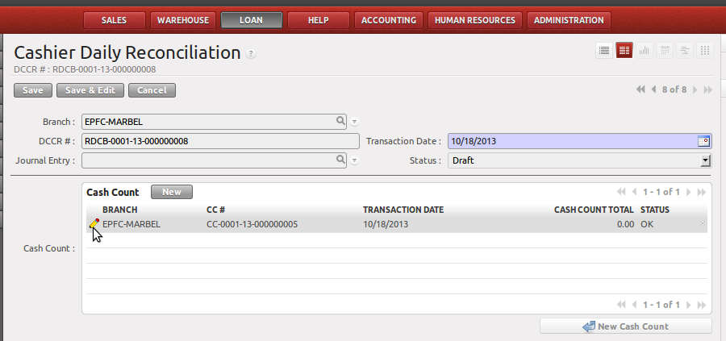
A new record will be created. Click the PENCIL icon to add the cash count.

Step 2: Input Cash Count per denomination.
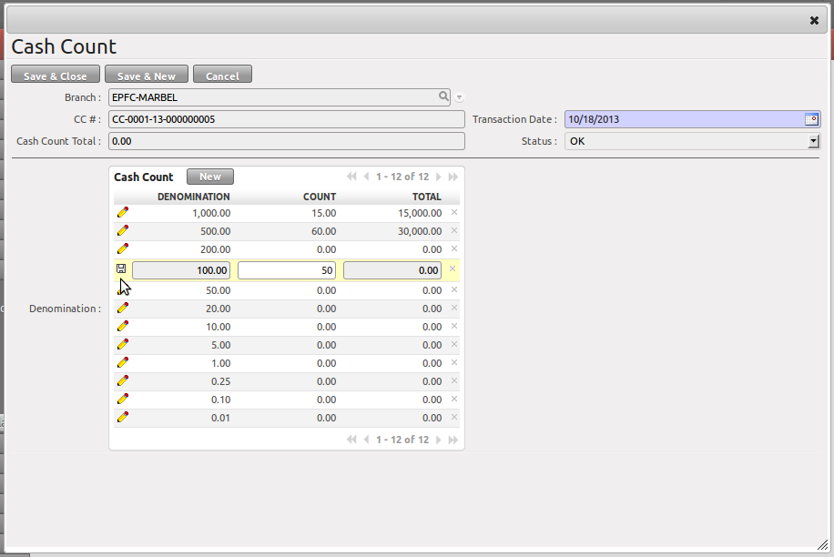
Click the COUNT column to edit the cash count per denomination. Click the DISK button to save the line. Click SAVE AND CLOSE button to go back to the previous screen.

Click the SAVE button in the main form to commit all the changes made in the record.

Please note that you can create multiple cash count per RDCB but only one RDCB is allowed per branch per day.

User: ACCOUNTING ASSISTANT

Step 1: Click the RECONCILE Button
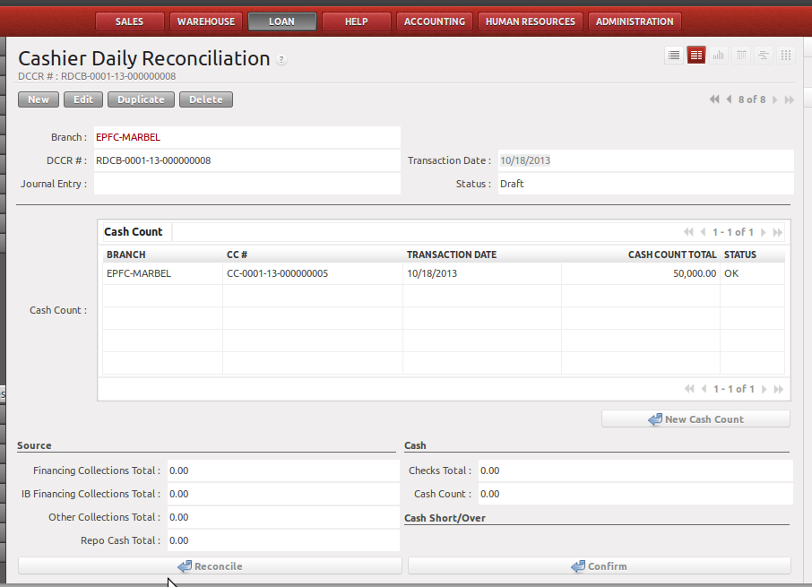
After clicking the RECONCILE button Cash Short/Over will be determined. If the short/over is validated, go to step 2.

Step 2: Click the CONFIRM Button

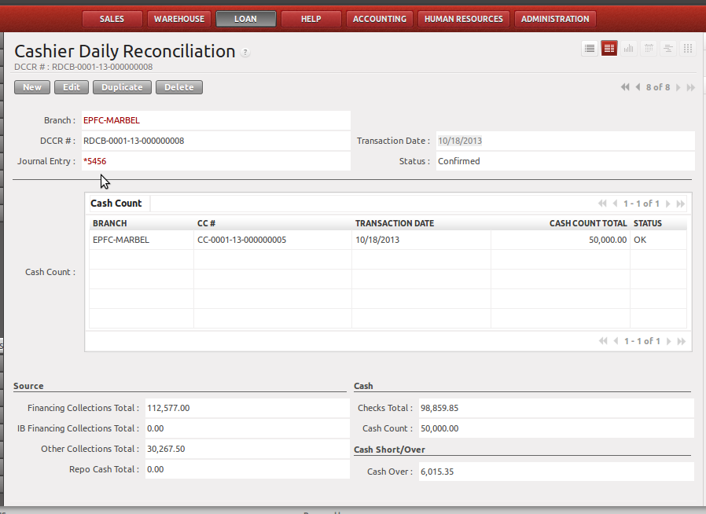
After the CONFIRM button is clicked, the Journal Entry will be automatically created. And the RECONCILE and CONFIRM buttons will not be available. Therefore, it is important to thoroughly check the Cash Short/Over before clicking the confirm button.

JOURNAL ENTRY
Account Title | DR | CR
Cash Shortage
Cash Short/Over | XXX
Cash on Hand |  | XXX
Cash Overage
Cash on Hand | XXX
Cash Short/Over |  | XXX

